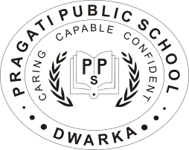 **PRAGATI PUBLIC SCHOOL**

**CLASS III**

**SESSION: 2018-19**



HOLIDAY HOMEWORK

**Dear students,**

We know that when you think of summer, you always think of fun filled activities such as; playing for longer hours, exploring new places, watching movies etc. Guess what; this holiday homework let you do all these things and more. Studies are important for us to gain knowledge, and sports are important to keep active, healthy and learn various personality traits. With this thought in mind, this year we teachers have designed your holiday homework to keep you actively and fruitfully engaged during summer break. Holidays are great, but school work can be fun filled and inspiring too if done on your own. Of course you can ask your parents for some help.

**Dear Parents,**

Warm greetings. For the past months we enjoyed taking care of your precious children. You might have noticed that they all loved coming to school. For the next six weeks, you, their natural guardian will spend the vacation with them. Let’s share some tips to make this period a fruitful and happy period for them.

* Have at least two meals together with your children.
* Allow your child to help you in cooking. Let them make their own vegetable and fruit salad.
* Allow your child to play outdoors get hurt and get dirty. It’s okay for them to fall down and experience pain once in a while. Comfortable life within the sofa cushions will make your child lazy.
* Look into the eyes of your little one and thank God for giving you one- wonderful gift. In few years from now, they will be soaring into greater heights.

**General instructions**:

1. Do homework as specified according to your roll number.

2. Follow all the given instructions sincerely.

Holiday homework should be submitted from 7th July, 2018 to 14th July, 2018.Revise all the units which been covered so far in all the subjects during summer vacations.



“FABRIC AND FASHION”

* Make an album on Indian fashion and accessories of the given ancient time periods-

|  |  |
| --- | --- |
| Roll no 1-7 | Indus Valley civilization period |
| Roll no 8-14 | Vedic period |
| Roll no 15-21 | Gupta period |
| Roll no 22-27 | Mughal period |
| Roll no 28-35 | Rajput period |

**NOTE- Make the album with A-3 sized sheets of 8-10 pages and paste coloured pictures in it.**

**\***Collect some colourful pictures from magazines, newspapers and internet of the dresses worn in the Modern times and write a paragraph on it in about 40-50 words on an A-3 sized sheet.

*Read newspaper daily and discuss the important news with your parents and update yourself.

*Visit the places of your interest with your parents and write a paragraph in about 80-90 words about your visit on an A-4” sized sheet and decorate with the pictures of the place.

*Collect the pictures of the kinds of nouns and make collage with pictures on A-4”sized sheets.



**QS”ku dh Mksj tM+kas dh vksj**

* uohu ;qx ds QS”ku vkSj iqjkus ;qx ds QS”ku esa D;k varj gS] mudks vius “kCnksa esa fp= lfgr 80 ls 100 “kCnksa esa ,&3 lkbt+ “khV ij fyf[k, A
* आदिकाल, वैदिक काल, गुप्त काल में प्रयोग होने वाले तरह-तरह के आभूषण बनाइए (आभूषण बनाने के लिए शंख, सिप्पी व अलग अलग पत्थरों आदि का प्रयोग कर सकते हैं)
* oL= QS”kuij ,d dfork fyf[k,A¼pquh xbZ dfork Ldwy if=dk esa NiokbZ tk,xh½
* djok, x, d{kkdk;Z dk vH;kl dhft,A



a) On an A3 sized sheet paste coloured pictures of the Brides and Grooms of the given states :-

*Any one North Indian States ( Roll No-1-9)

* Any one East Indian States (Roll No 10- 18)

* Any one West Indian States (Roll No 19-26)

* Any one South Indian States ( Roll No 27-35)

b) On an A3 sized sheet paste the sample of the given fabric and write their advantages :-

|  |  |  |
| --- | --- | --- |
| Roll no 1-12 | Roll no 13-22 | Roll no 23-35 |
| *Cotton | *Silk | *Chiffon |
| *Jute | *Linen | *Velvet |
| *Nylon | *Satin | *Crepe |
| *Rayon | *Georgette | *Denim |

c) **PROJECT WORK**

(1) Make collage of the following topics on A3 sized sheet-

*Dresses and accessories worn by(10,000 BC to 6,800 BC) **Early Man** ( Roll No1-12)

*Dresses and accessories worn during(1526 to 1857) **Mughal age** (Roll No 13-24)

\***Modern**  dresses and accessories of **Present age** ( Roll No 25-35)

(2) Design a dress that you would like to wear in the year 2030 along with the hairstyles in a fashion show. You can draw the sketch on an A 3 sized sheet.

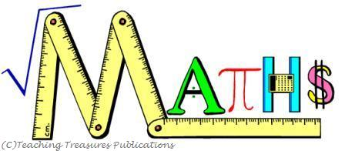

1) Make a woven table mat with two coloured strips using thick paper and write the tables on it from 2 to 10. Laminate the mat. Example:-

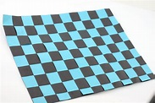Refer link -https://www.youtube.com/watch?v=vepHlcVQafw

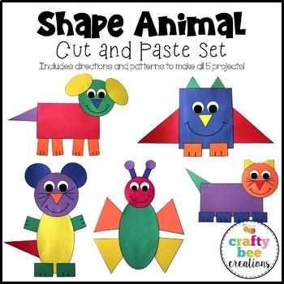2) Cut the different shapes from different kind of colourful fabric (cloth) and paste it on an A3 size sheet to form a figure or a pattern. EXAMPLE-

3) Cut the newspaper cutting which has 3 to 4 digit numbers, circle and write odd and even numbers, find out the sum and difference of those numbers. Paste and solve on the A4 size sheet.

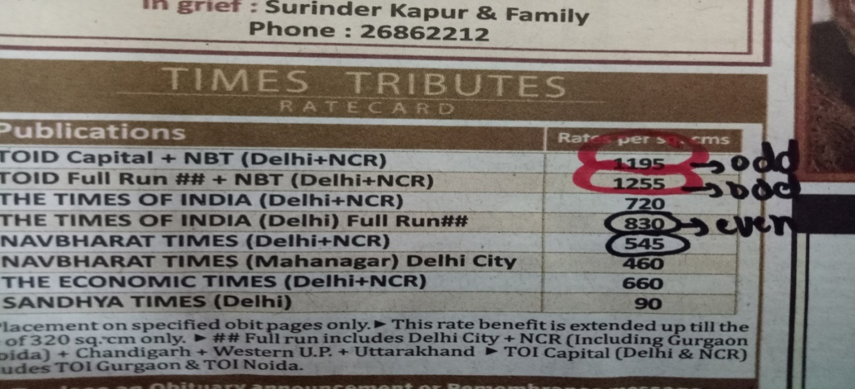

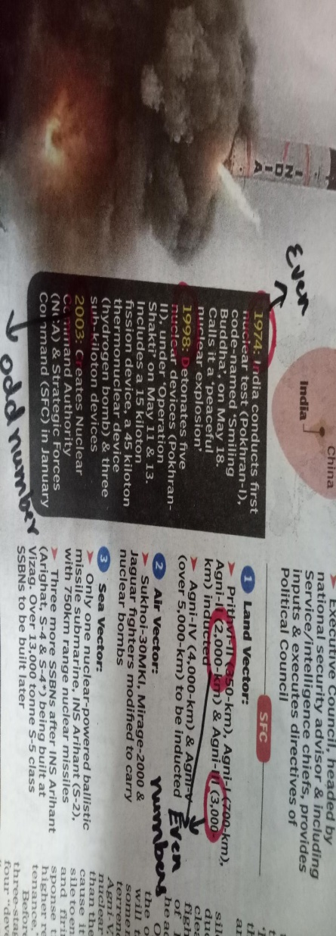

Have a cool and refreshing summer break!!!!

**HAPPY HOLIDAYS!!!**