PRAGATI PUBLIC SCHOOL , DWARKA
CLASS- II (2018-2019)
Holiday Homework

As the holidays have begun,
it’s time for us to have some fun. It is time to see amazing kids’movies and help our mama in making goodies. We will make new friends and spend time with them. We got a big break from school,to enjoy the vacation and stay cool. We are free to do anything we like, playing, reading or riding our bike. We will sleep on time,and rise with the bright sun. As the holidays have begun,
It’s time for us to have some fun.

Looking forward to meet to you all in July……….

Happy Holidays!!!!!!!

Have a great time!
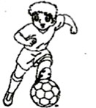Dear Parents

Kids look forward to the summer vacation all year long. They look forward to having loads of fun and family time. With summer vacation right around the corner, its time to generate certain ideas to help children have a memorable vacation.

Growing your children’s talent

Help your children learn a sport or join talent class this summer. While learning new skill/ sport, children stay active and attentive.

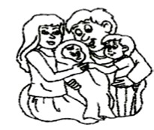Creating a family bond

Along with varied activities, kids enjoy meeting people. Summer vacation is the best time to visit other members of the family who do not live in town. Kids really love the presence of Grandparents, aunts and uncles in their lives.
It ensures stronger family ties as well.

Inculcating Reading Skills

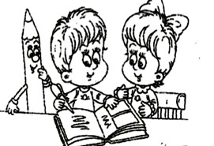Get your children exposed to the fascinating world of fictitious characters through interesting story books. However, throw in some non-fiction reading as an added advantage.

Cyber Fun: Few suggested internet sites to visit:

www.pitara.com, www.funbrain.com, www.magickeys.com (reading books), www.nationalgeographic.com

Involving In Household Chores

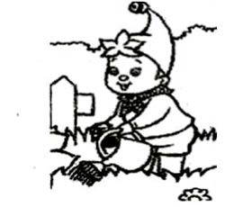Assign your children a few tasks which they can easily accomplish like filling water bottles, keeping them in the refrigerator, watering the plants, cleaning dishes, folding washed clothes etc. This is how you can get your young ones get into the habit of helping out around the house. You will set a pattern that will benefit them when they grow up.

Splash in water: Have fun while washing your own handkerchiefs, underpants and socks.

Note: A happy and healthy family time is the best way of imparting the much needed life skills to our children. We all wish to see them grow up as responsible and caring individuals who understand the value of time.
Celebrate your family and have a wonderful time together!

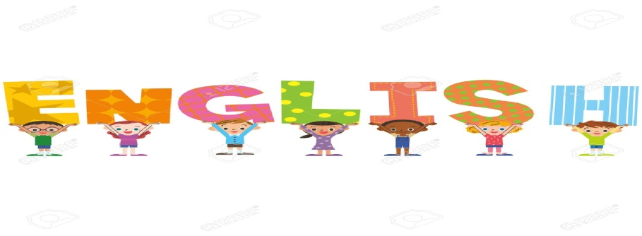
1.Design the logo for the following channel and write a few lines on what it symbolizes, how it originated and how the channel began broadcasting. On A3 size coloured sheet.

Roll no | Sub-heading for logo
1-7 | News Channnel
8-14 | Sports Channel
15-21 | Cartoon Channel
22-28 | Food and Lifestyle Channel
29-35 | Entertainment Channel

- Read English newspaper everyday. Write 2 new words with their meanings and prepare a pocket dictionary. 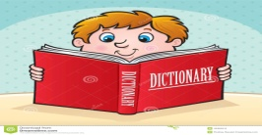
- Do one page of handwriting everyday (in a four lined notebook). Refer to the writing pattern.

1.Make catchy jingles to advertise your product. Present it on A3 size coloured sheet.

Roll no | Product | Examples
1-7 | Stationary Items | Pen, pencil, ruler, eraser etc..
8-14 | Clothing | Jeans, Jeggings, Socks etc.
15-24 | Beauty Products | Creams, lotions, perfumes,hairoils,shampoos etc.
25-30 | Footwear | Slippers, floaters, shoes etc.
31-35 | Food Items | Vegetables, fruits etc.

2. Make a collage on A3 size coloured sheet on-

Roll n.o | Topic
1-12 | Mass media in the ancient times (letters, scrolls by king, pigeon, telegrams, post cards, envelope, radio etc.)
13-26 | Mass media in the present time (newspaper, magazine,comics, news channel, social media, broadcasting, Kindle etc)
27-35 | Mass media in the future era (e-volume, virtual learning, cloud computing etc.)

3. Revise the following chapters thoroughly:-

Chapter-3 Wild animals
Chapter-4 Animals that help us
Chapter-5 Bones and muscles.

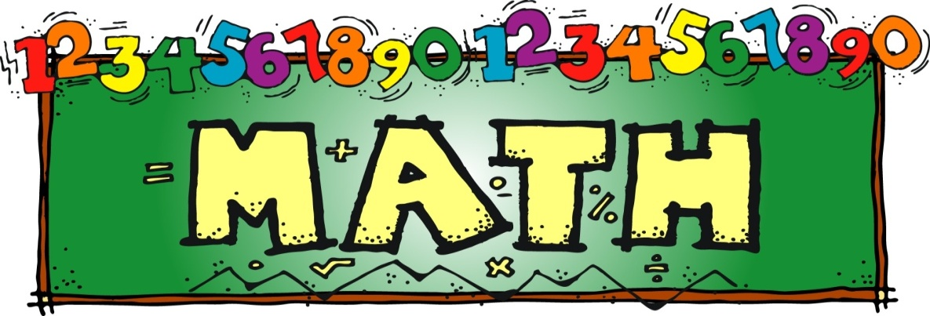
- Research Work

Roll No 1 TO 13

Collect and tabulate data on the number of hours in a day spent by you in various forms of media for 10 days.

 | Number of hours spent on-
DAY | PRINT MEDIA  (Newspapers,magazines,  Books etc) | ELECTRONIC MEDIA  (Television, computer, Mobile etc.)
1.
2.

Roll No 14 to 25

Conduct a survey among your family members and tabulate the number of hours spent by them on various social networking sites.
*Data should be collected for a minimum of 10 family members.

S.No. | Relation with the family member | Networking site  (Facebook,whatsapp etc) | Number of hours spent in a day
1.
2.

ROLL NO 26 TO 35

Conduct a survey and collect data on the most preferred media among your family members to share and communicate information.
*Survey strength-10
 |  | Media preferred
S.No. | Relation with the family member | Social networking site | Newspaper | Magazine
1.
2.

- All research work should be presented on A3 Size coloured sheets.
- Cut out any five (3-digit numbers) from newspaper, paste them on A4 size coloured sheet and write their expanded form.
- Revise number names from 1 to 200.
- Revise the shapes done in class (square, circle, rectangle, triangle, cube, cuboid, cylinder, cone, sphere). Use these shapes to create an amusement park through your imagination. Origami sheets can be used to present your work on an A3 size sheet.

Project work

Make a 3-D model using cardboard and decorative material as per the topics assigned to your section and roll no.
Accompany your model with a Description of the same written on an A3 size coloured sheet representing the information of the model displayed by you.

Section A- Evolution of television

Section B - Journey of telephones

Section C- Roadmap of computers

Section D - Timeline of camera

Section E- Evolution of satellites 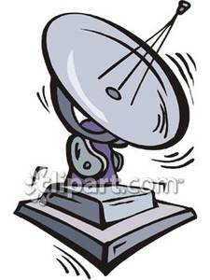

The below table represents the order of Roll No. And timeline to be followed by each section for the specific topic allocated to the section . Please refer to the Sub heading provided to your section and corresponding Roll No. prior to making the Models.

Roll No. | Timeline
1-12 | 1855-1960
 | 1960-1990
13-24 | 1990-2000
 | 2000-2010
25-35 | 2010-present
 | Present- future

You can refer to the following links:-
https://www.wikipedia.org/

https://youtu.be/_G544eM86Rw
https://youtu.be/ZewQhyQce4U
https://youtu.be/xBrUL0y_a_w
https://youtu.be/7Jz1qpv3Pm8
https://youtu.be/oNo98ZrukQU

Hindi
- सोशल नेटवर्किंग साइट्स का बढ़ता दौर, इस विषय में A-3 साइज़ शीट पर सुंदर चित्र बनाकर कविता लिखिए-
- रोल न- 1 से 20 फेसबुक पर कविता लिखें!
- रोल नं – 21-35 वोट्सऐप पर कविता लिखें!
(नोट- कविता बोल्ड मार्कर से लिखी गई हों व शीट को लैमिनेट भी करवाएं!)
- ) विद्यालय की पत्रिका के लिए A-3 साइज़ शीट पर सुंदर लेख लिखें!
- ) A-3 साइज़ शीट पर मात्राओं का सुंदर चार्ट बनाएँ-
- रोल न 1-5 “अ” मात्रा और “आ” मात्रा
- रोल न 6-10 “इ” मात्रा और “ई” मात्रा
- रोल न 11-15 “उ” मात्रा और “ऊ” मात्रा
- रोल न 16–20 ”ऋ” मात्रा और “ए” मात्रा
- रोल न 21–25 “ऐ” मात्रा और “ओ” मात्रा
- रोल न 26-30 “औ” मात्रा और “अं” मात्रा
- रोल न 31-35 “अ:” मात्रा और “श्र” वाले शब्द
(नोट- सभी मात्राएँ बोल्ड मार्कर से लिखी गई हों व शीट को लैमिनेट भी करवाएं!)
- ) कक्षा में करवाया गया सभी कार्य याद करें!

HAPPY HOLIDAYS !!!

